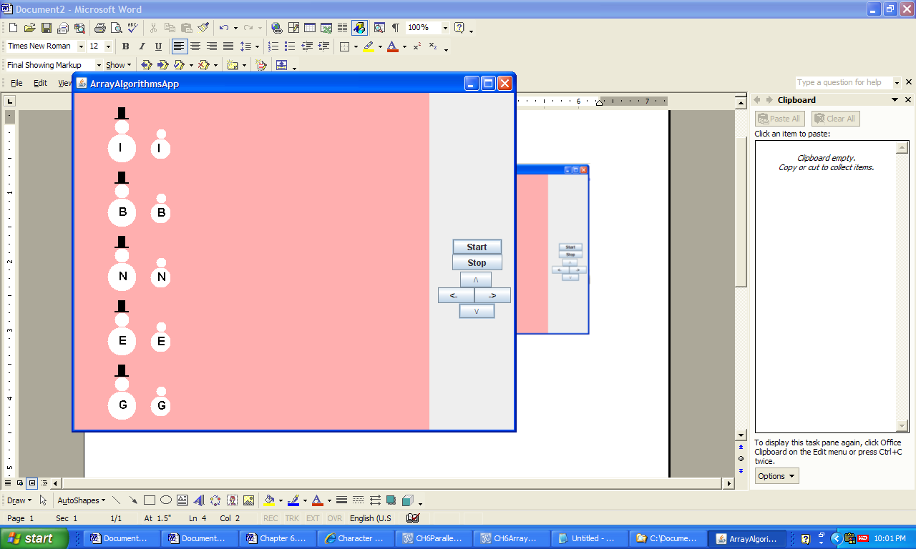 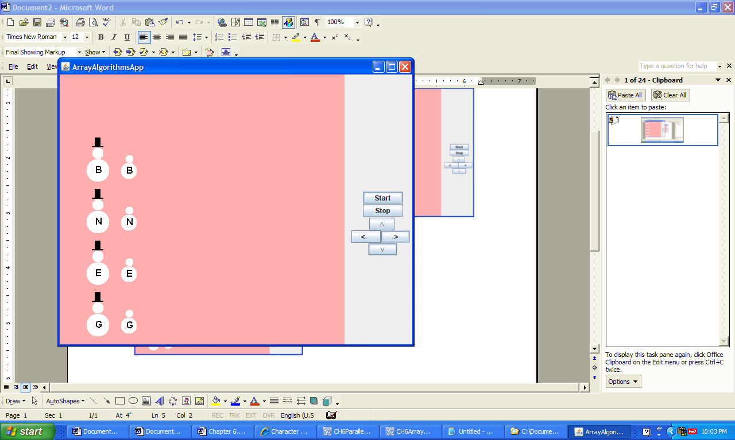

**a) After the Program is Launched b) After the Key I is Struck the 1st Time**

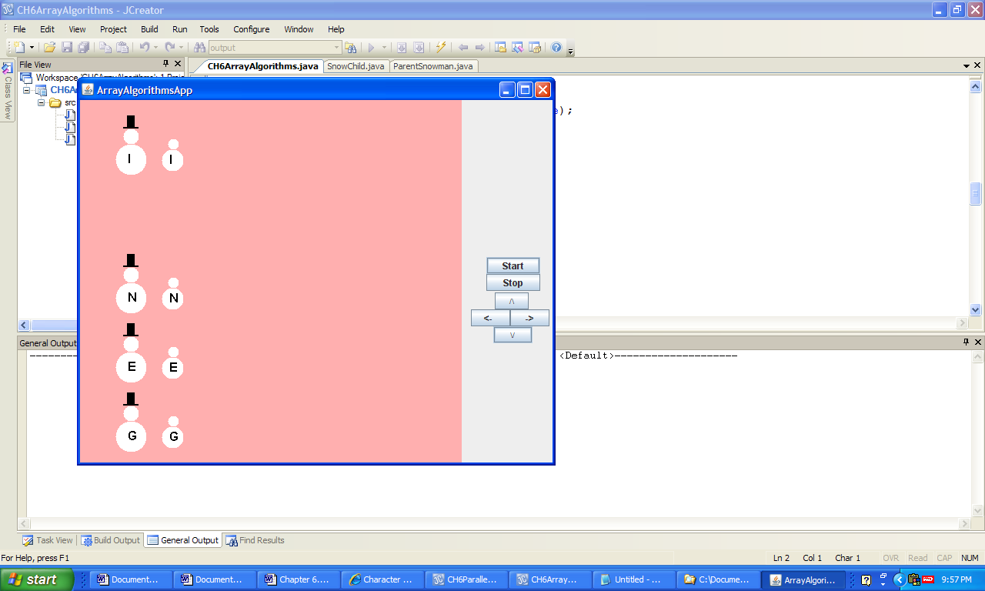 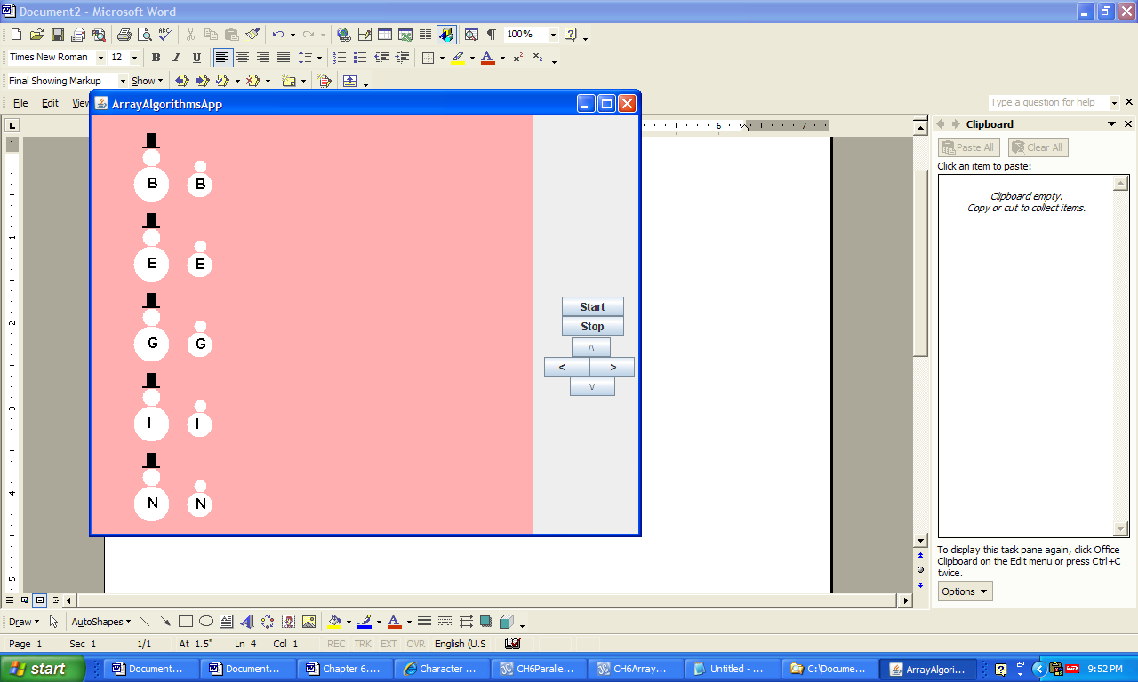

**c) 2nd Strike of "I" Followed by d) After Key "S" is Struck**

**a Strike of the Up Cursor Key**

**Figure 6.25 The graphical output of the application ArrayAlgorithms.**